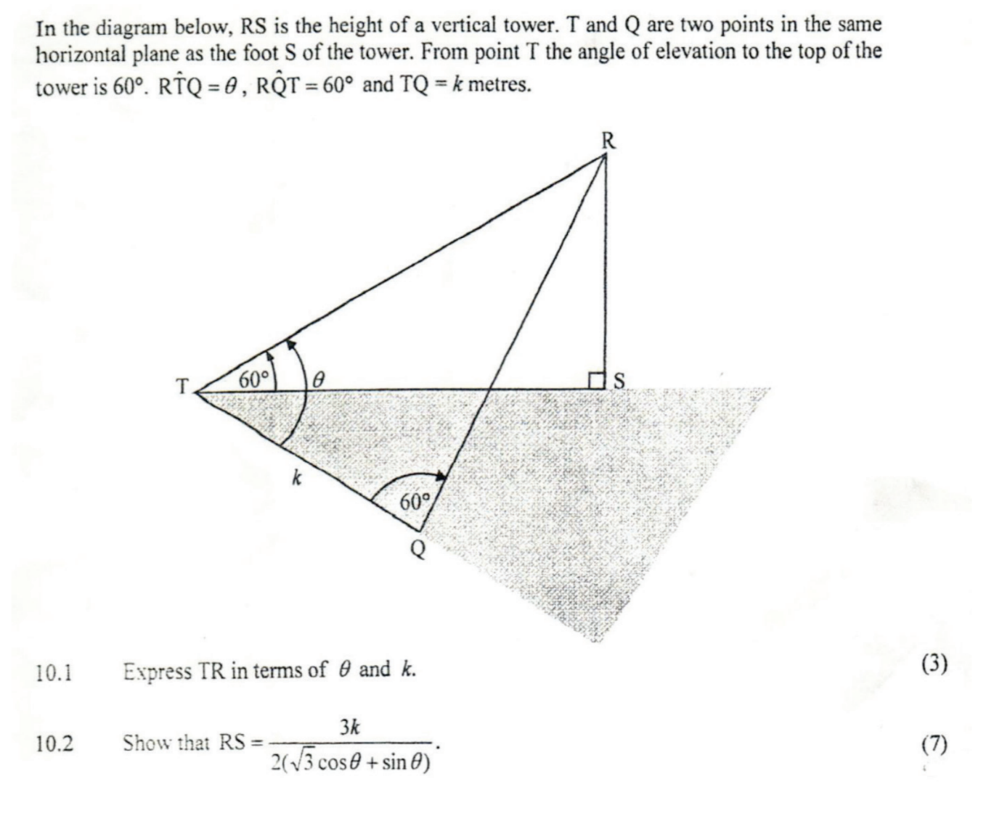

$$TR=\sqrt{k^{2}+{RQ}^{2}–2k\left(RQ\right)cos60}$$
$$\frac{RQ}{sinθ}=\frac{k}{sin(180–60–θ)}=\frac{k}{sin120cosθ–cos120sinθ}=\frac{k}{\frac{\sqrt{3}cosθ}{2}+\frac{1}{2}(sinθ)}=\frac{2k}{\sqrt{3}cosθ+sinθ}$$
$$RQ=\frac{2k sinθ}{\sqrt{3}cosθ+sinθ}$$
$$TR=\sqrt{k^{2}+(\frac{2k sinθ}{\sqrt{3}cosθ+sinθ})^{2}–2k(\frac{2k sinθ}{\sqrt{3}cosθ+sinθ})cos60}=$$
$$\sqrt{k^{2}+(\frac{2k sinθ}{\sqrt{3}cosθ+sinθ})^{2}–\frac{2k(\frac{2k sinθ}{\sqrt{3}cosθ+sinθ})}{2}}=$$
$$\sqrt{k^{2}+(\frac{2k sinθ}{\sqrt{3}cosθ+sinθ})^{2}–\frac{2k sinθ}{\sqrt{3}cosθ+sinθ}}=$$
$$\sqrt{k(k+(\frac{2 sinθ}{\sqrt{3}cosθ+sinθ})^{2}–\frac{2sinθ}{\sqrt{3}cosθ+sinθ})}$$

cos60 = $\frac{1}{2}$ = $\frac{TS}{TR}$ = $\frac{TS}{\sqrt{k(k+(\frac{2 sinθ}{\sqrt{3}cosθ+sinθ})^{2}–\frac{2sinθ}{\sqrt{3}cosθ+sinθ})}}$
TS = $\frac{\sqrt{k(k+(\frac{2 sinθ}{\sqrt{3}cosθ+sinθ})^{2}– \frac{2sinθ}{\sqrt{3}cosθ+sinθ})}}{2}$

RS = $\sqrt{{TR}^{2}–{TS}^{2}}$ =
$$\sqrt{(k(k+(\frac{2 sinθ}{\sqrt{3}cosθ+sinθ})^{2}–\frac{sinθ}{\sqrt{3}cosθ+sinθ}))) – \frac{k(k+(\frac{2 sinθ}{\sqrt{3}cosθ+sinθ})^{2}–\frac{sinθ}{\sqrt{3}cosθ+sinθ})}{4}}$$
$$\sqrt{k((k+(\frac{2 sinθ}{\sqrt{3}cosθ+sinθ})^{2}–\frac{sinθ}{\sqrt{3}cosθ+sinθ})–\frac{k+(\frac{2 sinθ}{\sqrt{3}cosθ+sinθ})^{2}–\frac{sinθ}{\sqrt{3}cosθ+sinθ}}{4}))}$$
$$\sqrt{\frac{k}{\sqrt{3}cosθ+sinθ}((k+(2 sinθ)^{2}–sinθ)–k+sinθ(\frac{4 sinθ}{3cos^{2}θ+2\sqrt{3}cosθsinθ+sin^{2}θ}–\frac{1}{\sqrt{3}cosθ+sinθ}) x \frac{1}{4})}$$
$$\sqrt{k((k+(\frac{2 sinθ}{\sqrt{3}cosθ+sinθ})^{2}–\frac{sinθ}{\sqrt{3}cosθ+sinθ})–k+(\frac{sinθ}{\sqrt{3}cosθ+sinθ}(4sinθ–1) x\frac{1}{4})))}$$
https://www.symbolab.com/solver/step-by-step/simplify%20%5Csqrt%7Bk%5Cleft(%5Cleft(k%2B%5Cleft(%5Cfrac%7B2sinx%7D%7B%5Csqrt%7B3%7Dcosx%2Bsinx%7D%5Cright)%5E%7B2%7D-%5Cfrac%7Bsinx%7D%7B%5Csqrt%7B3%7Dcosx%2Bsinx%7D%5Cright)-k%2B%5Cleft(%5Cfrac%7B%5Cfrac%7Bsinx%7D%7B%5Csqrt%7B3%7Dcosx%2Bsinx%7D%5Cleft(4sinx-1%5Cright)%7D%7B4%7D%5Cright)%5Cright)%7D
Where x = $θ$:
